Cal Poly Pomona

Deshol John

Zozo Company Database Models

February 28, 2024

CIS 3050

Section 5

Spring 2024

# Table of Contents

Table of Contents 2

Student’s Academic Honesty 3

Introduction/ Project Description and Requirements 4

Introduction 4

Project Description 4

Attributes, Keys, Null/Not Null Data Type Table 5

Conceptual and Logical ERDs 7

Conceptual ERD 7

Logical ERD 7

Business Rules, Additional Business Rules 8

Erwin and Visio Physical ERDs 9

Erwin Physical ERD 9

Visio Physical ERD 9

Enhanced ERD 10

Schema for All RELATIONS 11

Referential Integrity Constraints 12

Functional Dependencies and First Normal Form 13

Full Functional Dependency 13

First Normal Form 13

Second and Third Normal Forms 14

Second Normal Form 14

Third Normal Form 14

Lessons Learned & Recommendations 15

Conclusion 15

References 16

# Student’s Academic Honesty

Statement of Academic Honesty

My name is: ____Deshol John_______, I declare that, except where fully referenced, no aspect of this project has been copied from any other source. I understand that any act of Academic Dishonesty such as plagiarism or collusion may result in serious offense and punishments. I promise not to lie about my academic work, to cheat, or to steal the words or ideas of others, nor will I help fellow students to violate the Code of Academic Honesty.

Name: ______Deshol John______

Date: ______2/28/2024_________

Signature: _____Deshol John_________

# Introduction/ Project Description and Requirements

## Introduction

The following project is for Zozo Company. I, with the help of a group although submitted individually was tasked by the company to describe their primary business processes. In order to complete this I had to develop a normalized relational data model. The model involves designing a complete database management system. The need for this is to address a practical database while implementing a relational database based on that design. Using Erwin database model I’m aiming to assist Zozo Company with performing general information management tasks. This will be through multiple deliverables such as Entity Relationship Diagrams (ERDs) both physical and logical, Logical Schema Diagrams, Referential Integrity Constraints Diagrams, and a few more which you will see in the following pages. The database team conducted research and provided me with rules and requirements I must follow to help achieve Zozo Company’s objective. The following pages will also show the extracted requirements from the database team.

## Project Description

The project is designing a complete database management system to address a practical database need and implement a relational database based on that design. Your database system should be designed to perform general information management tasks such as systematic

collection, update, and retrieval of information for a small organization.

The objective of Project #1 is to develop a normalized relational data model describing the primary business processes of the Zozo Company. The sales department of Zozo company has decided to create a database that contain the details of its sales process. The initial entities for your model are **REGION**, **STORE**, **PRODUCT**, **CUSTOMER**, and **VENDOR**. In addition to these initial entities, you are provided with several business rules.

# 

# Attributes, Keys, Null/Not Null Data Type Table

|  |  |  |  |  |
| --- | --- | --- | --- | --- |
| Entity | Attributes | Key | Data Type | Null/Not Null |
| Region |  |  |  |  |
|  | RegionID | Primary Key | UNIQUEID(9) | Not Null |
|  | RegionName | Non Key | CHAR(18) | Null |
| Store |  |  |  |  |
|  | StoreID | Primary Key | UNIQUEID(9) | Not Null |
|  | StoreZipCode | Non Key | CHAR(5) | Null |
|  | RegionID | Foreign Key | UNIQUEID(9) | Null |
| Customer |  |  |  |  |
|  | CustomerID | Primary Key | UNIQUEID(9) | Not Null |
|  | CustomerName | Non Key | CHAR(18) | Null |
|  | CustomerZip | Non Key | CHAR(5) | Null |
| Vendor |  |  |  |  |
|  | VendorID | Primary Key | UNIQUEID(9) | Not Null |
|  | VendorName | Non Key | CHAR(18) | Null |
| Category |  |  |  |  |
|  | CategoryID | Primary Key | UNIQUEID(9) | Not Null |
|  | CategoryName | Non Key | CHAR(18) | Null |
| Product |  |  |  |  |
|  | ProductID | Primary Key | UNIQUEID(9) | Not Null |
|  | ProductName | Non Key | CHAR(18) | Null |
|  | ProductPrice | Non Key | CHAR(18) | Null |
|  | VendorID | Foreign Key | UNIQUEID(9) | Null |
|  | CategoryID | Foreign Key | UNIQUEID(9) | Null |
| Transaction |  |  |  |  |
|  | TransactionID | Primary Key | UNIQUEID(9) | Not Null |
|  | TransactionDate | Non Key | CHAR(8) | Null |
|  | StoreID | Foreign Key | UNIQUEID(9) | Null |
|  | CustomerID | Foreign Key | UNIQUEID(9) | Null |
| Sales Transaction Product |  |  |  |  |
|  | TransactionID | Foreign Key | UNIQUEID(9) | Not Null |
|  | ProductID | Foreign Key | UNIQUEID(9) | Not Null |
|  | STP Quantity | Non Key | INTEGER(3) | Null |

# Conceptual and Logical ERDs

## Conceptual ERD

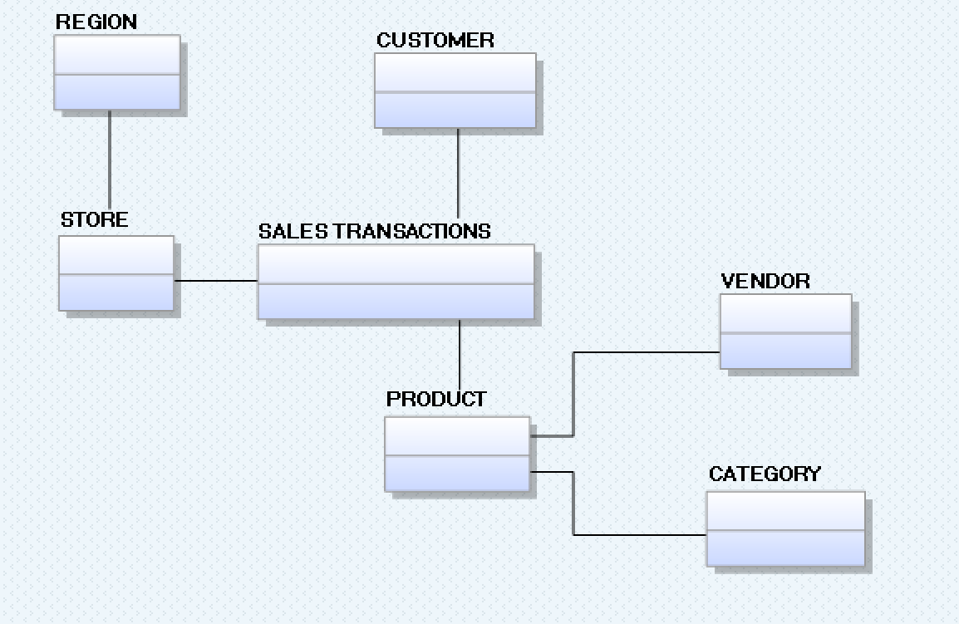

## Logical ERD

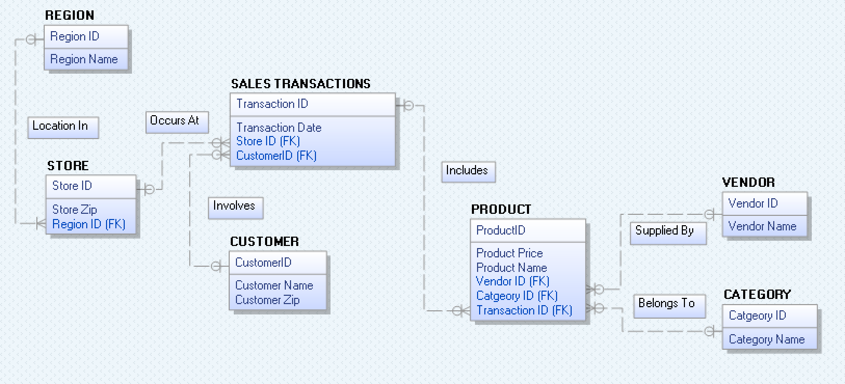

# Business Rules, Additional Business Rules

Zozo Retail Company sales Database will capture data about the  
following:  
· For each **product** being sold: a product ID, product name, and price;  
· For each **category** of product: category ID and category name;  
· For each **vendor**: vendor ID and vendor name;  
· For each **Customer**: customer ID, name, and zip code;  
· For each **store**, store ID, and zip code;  
· For each **region**: region ID and region name;  
· For each sales transaction: transaction ID, and date of Transaction;  
· Each product is supplied by exactly one vendor. Each vendor supplies one or more products.  
· Each product belongs to exactly one category. Each category contains one or more products.  
· Each store is located in exactly one region. Each region contains one or more stores.  
· Each **sale transaction** occurs in one store. Each **store** has one or more transactions occurring at it.  
· Each **sales transaction** involves exactly one **customer**. Each **customer** can be involved in one or **more transactions**.  
· Each **product** is included in one or more sales transactions. Each **sales transaction** includes one or more **products**.  
· For each **instance** of a product included in a sales transaction, the quantity of that product included (sold) in that transaction is required.  
· Each customer is shopping in many stores. Each store has many customers.  
· Each store contains many products. Each product contained in many stores.

# 

# Erwin and Visio Physical ERDs

## Erwin Physical ERD

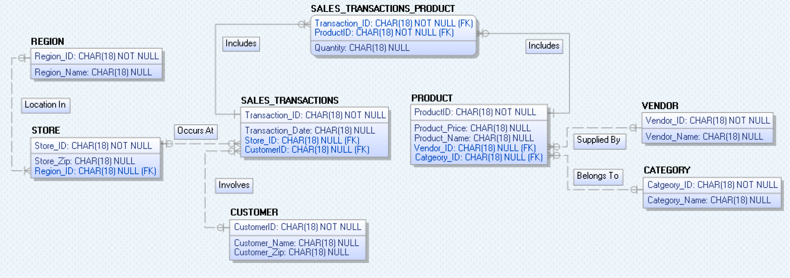

## Visio Physical ERD

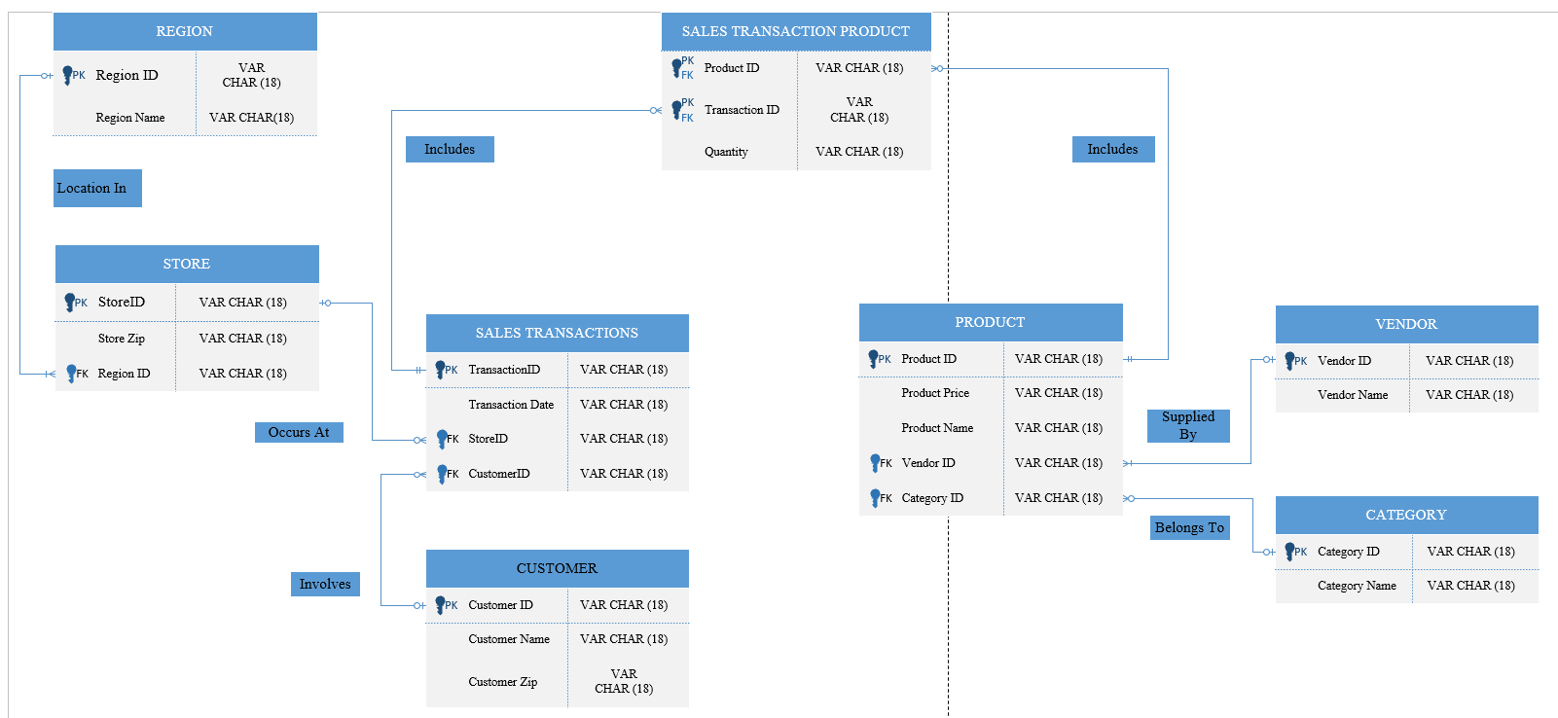

# Enhanced ERD

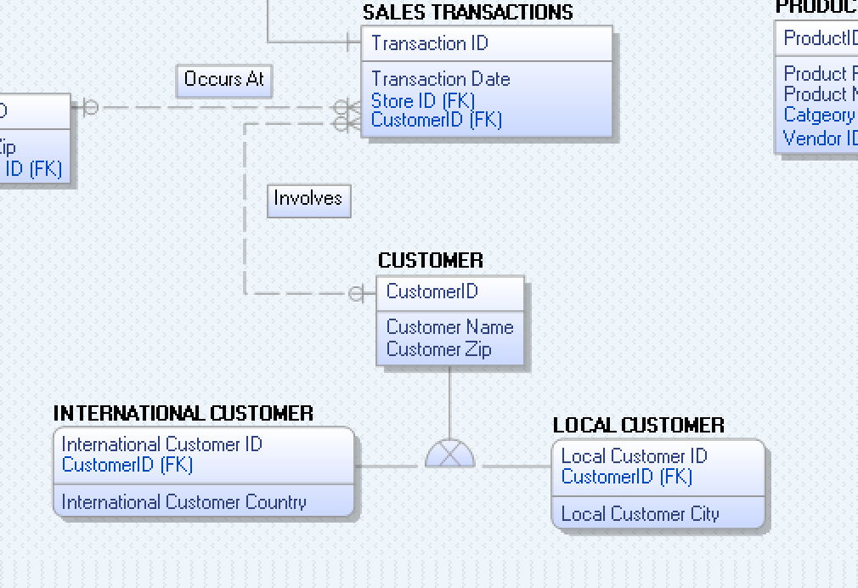

# Schema for All RELATIONS

Schema All RELATION

Region

|  |  |
| --- | --- |
| RegionID | Region Name |

Store

|  |  |  |
| --- | --- | --- |
| StoreID | Store Zip Code | RegionID |

Sales Transactions

|  |  |  |  |
| --- | --- | --- | --- |
| TransactionID | Transaction Date | StoreID | CustomerID |

Customer

|  |  |  |
| --- | --- | --- |
| CustomerID | Customer Name | Customer Zip |

Sales Transactions Product

|  |  |  |
| --- | --- | --- |
| TransactionID | ProductID | Quantity |

Product

|  |  |  |  |  |
| --- | --- | --- | --- | --- |
| ProductID | Product Price | Product Name | VendorID | CategoryID |

Vendor

|  |  |
| --- | --- |
| VendorID | Vendor Name |

Category

|  |  |
| --- | --- |
| CategoryID | Category Name |

# Referential Integrity Constraints

Referential Integrity Constraints

Region

|  |  |
| --- | --- |
| RegionID | Region Name |

Store

|  |  |  |
| --- | --- | --- |
| StoreID | Store Zip Code | RegionID |

Sales Transactions

|  |  |  |  |
| --- | --- | --- | --- |
| TransactionID | Transaction Date | StoreID | CustomerID |

Customer

|  |  |  |
| --- | --- | --- |
| CustomerID | Customer Name | Customer Zip |

Sales Transactions Product

|  |  |  |
| --- | --- | --- |
| TransactionID | ProductID | Quantity |

Product

|  |  |  |  |  |
| --- | --- | --- | --- | --- |
| ProductID | Product Price | Product Name | VendorID | CategoryID |

Vendor

|  |  |
| --- | --- |
| VendorID | Vendor Name |

Category

|  |  |
| --- | --- |
| CategoryID | Category Name |

# Functional Dependencies and First Normal Form

## Full Functional Dependency

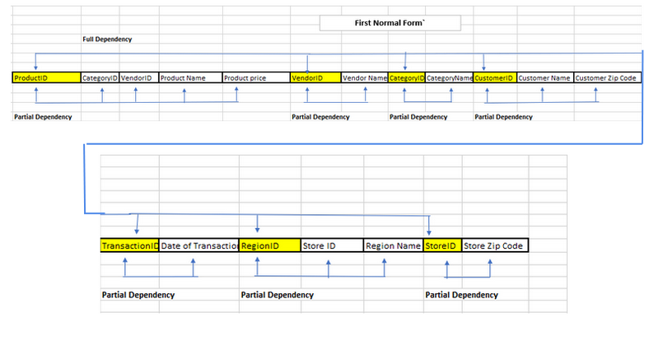

## First Normal Form



# Second and Third Normal Forms

## Second Normal Form

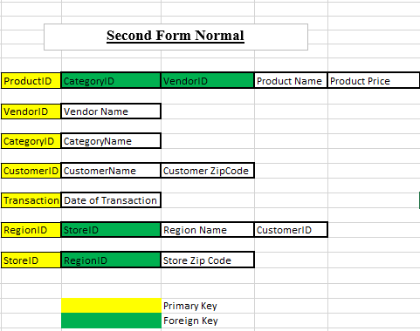

## Third Normal Form



# Lessons Learned & Recommendations

Upon completing this project I found it difficult yet eye opening. There were a lot of obstacles and moments of confusion on the road to completion. I learned numerous amounts of things apart from just learning how to use Erwin. Although that was my main learning factor, I was able to learn more about businesses processes through the software. Learning about entities, attributes, and relationships allowed me to discover a side of databases that knew little to nothing about. By drawing out graphical versions of the deliverables on the software I was able to further grasp what was taught in class to me. Since I am a hands-on learner, the graphs started to make more sense once applying the knowledge learned in class to Erwin. In addition to the re-enforcements of the concepts I learned that it’s extremely important to work close with the company whom you are working for. A company may not always provide all their business rules upfront so it’s important to communicate thoroughly to understand what they want. Developing the database management system is difficult without all the details known in the beginning. For my recommendation on this project I would recommend to confirm with the company on project vision and updates as you complete the processes. Also to not use Visio as it was slow and a bit more tedious to use in my opinion.

## Conclusion

In conclusion, creating a database management system for Zozo Company was not an easy process. As stated above in my lessons learned the project contained numerous obstacles all the up until the finish line. Some of which were not as difficult than others. Learning the Erwin software was the first of many obstacles within the project. Through the help of my Database Design and Development class and playing around with Erwin for a few hours I was able to get the hang of it. In addition, after I reviewed the rules and requirements from Zozo’s database team the project only started to get clearer from that point on. I was able to help Zozo company perform general information management tasks through Logical and Physical ERDs, Schema Diagrams, Referential Integrity Constraints Diagrams, and etc…. Each diagram constructed allowed me to overall describe Zozo company’s primary business processes.

# References

Hoffer, Jeff, et al. Modern Database Management. Available from: VitalSource Bookshelf, (13th Edition). Pearson Education (US), 2018.

(https://www.erwin.com/products/erwin-data-modeler/)

*Relationships and Domains*, bookshelf.erwin.com/bookshelf/public_html/12.5/Content/User%20Guides/erwin%20Help/Relationships%20and%20Domains.html. Accessed 26 Feb. 2024.

*Logical and Physical Modeling*, bookshelf.erwin.com/bookshelf/public_html/12.5/Content/User%20Guides/erwin%20Help/Logical_and_Physical_Modeling.html. Accessed 26 Feb. 2024.

Database Tutorial for Beginners https://www.youtube.com/watch?v=wR0jg0eQsZA